[1] Download Git:-
https://git-scm.com/downloads
[2] Check which version of Git installed. Open command prompt as admin:-
git --version
or,
Open git Bash and type:-
git --version
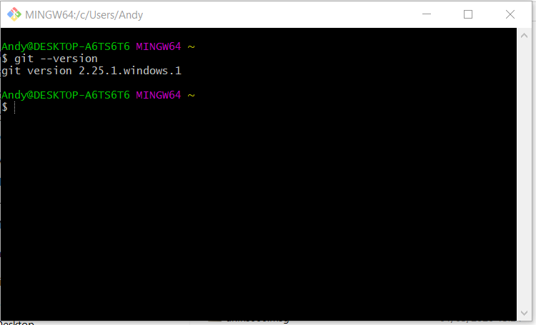
[3] Configure a user:-
Open Git Bash, then type:-
Configure name:-
git config --global user.name ‘Andy Short’
Configure email:-
git config --global user.email divine.moment.of.truth1@gmail.com
Verify that these changes have been set:-
git config --list
User Git Help to find out what git commands do *typing the following into GitBash will open a browser:-
git help add

Creating first git repository:-
Type the following into GitBash to find out your current working directory:-
pwd
This will return this:-
/c/Users/Andy

Create a folder on your desktop called:-
Andy

Navigate to the folder above in GitBash:-
Type the following to see what folder are in your present location:-
ls
Then type:-
cd Desktop
cd Andy

Turn this folder (Andy) into a git repository by typing the following into GitBash:-
git init

This creates this:-
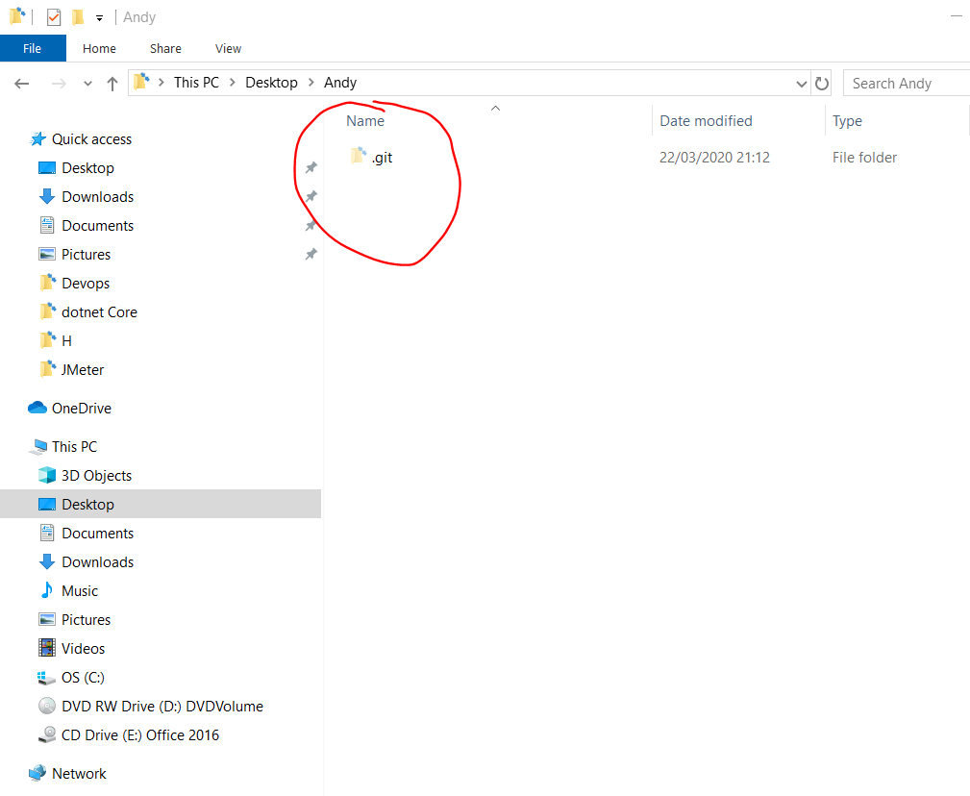

First Git Commit:-
Open GitBash in your project folder (the folder when the .git folder exists). Navigate to the folder in windows explorer and right click within the folder and select ‘Git Bash Here’:-
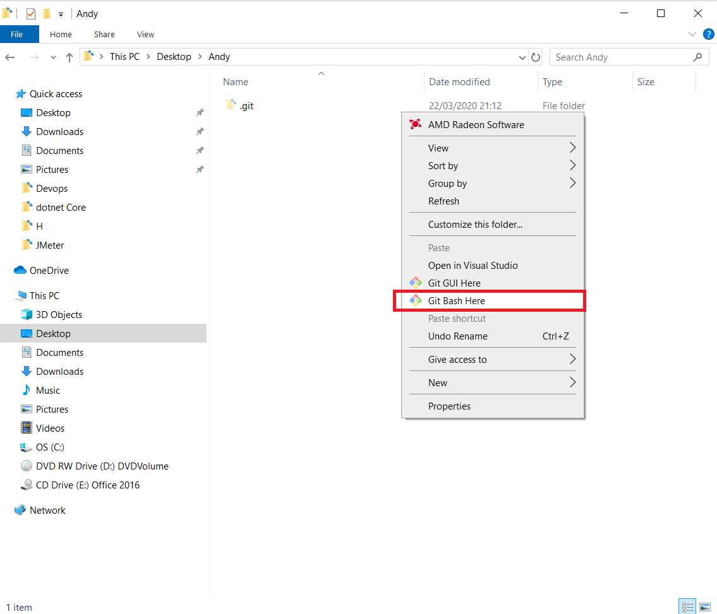

The type:-
ls -la
This returns this:-
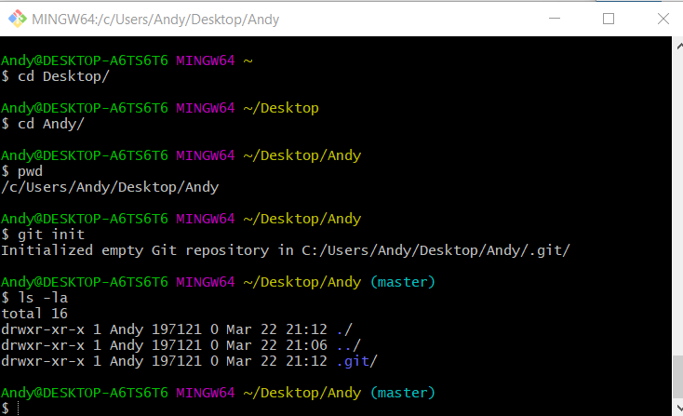

Type the following to see if there are any files to commit:-
git status

there are no files in this folder so create a dummy file:-
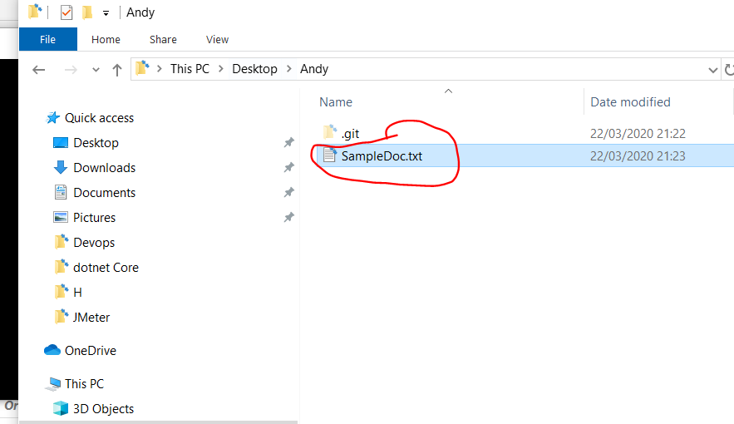
Type the following again:-
git status

This time you can see there is a file (highlighted in red):-
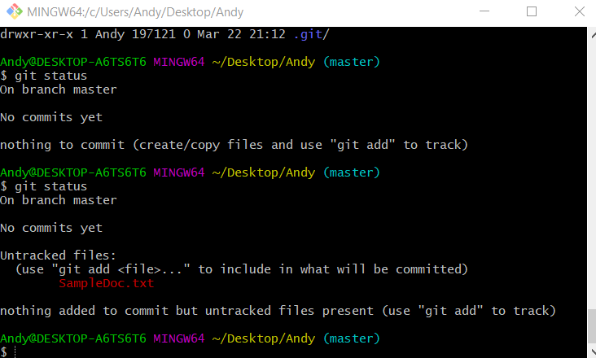

Type the following:-
git add .

Type the following:-
git status

You can add single files to the staging area by typing:-
git add filename.txt

You will see that the file is now green:-
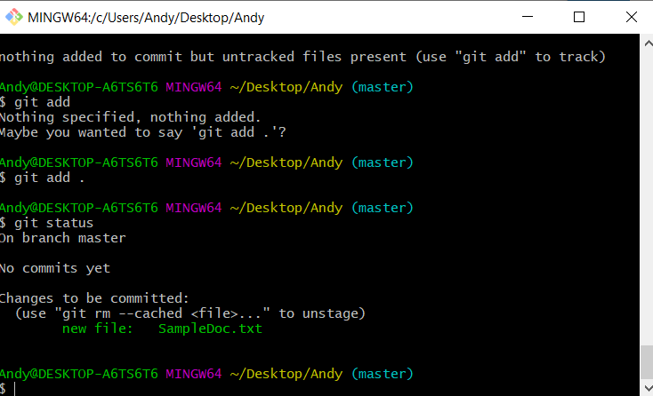

Now, commit the file to Git. Type the following:-
git commit -m ‘My first Git commit’

Now make some changes to your text file then save the file. Then type ‘git status’ in Git Bash:-
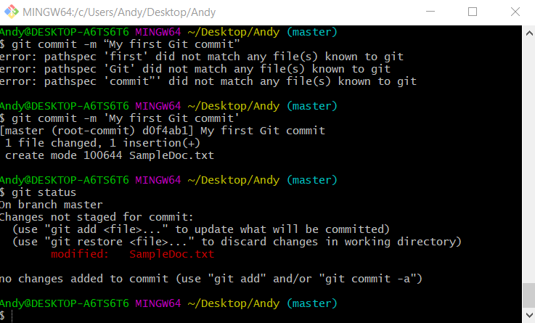
You will see that the file appears red again because it has changed.

Now type:-
git add .

Now type:-
git commit -m ‘second commit’

Adding Files and Commit Logs in Git
To view your commits type:-
git log
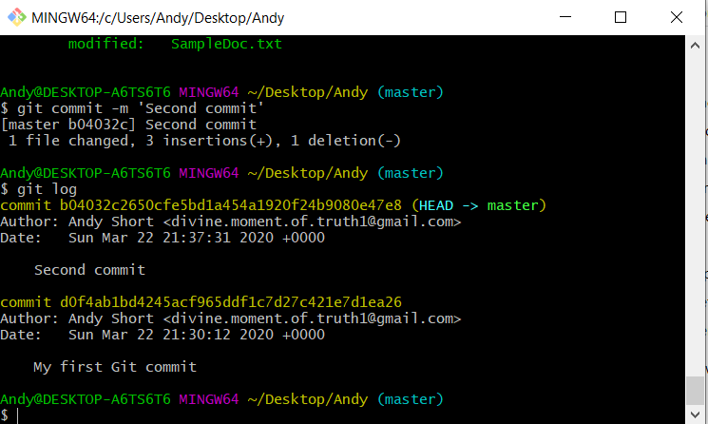
This shows the date and time of the Git commits.

If you want to see the git commits of a specific user type:-
git log --author=”Andy Short”

Git Workflow
Three areas:-
- Working Area
- Staging Area
- Repository

Text editor for Git
Notepad++
Bash Alias

Notepad++:-
Install notepad++
When installed go to where it is installed and copy the path:-
C:\Program Files (x86)\Notepad++
Add this path to environment variabes:-
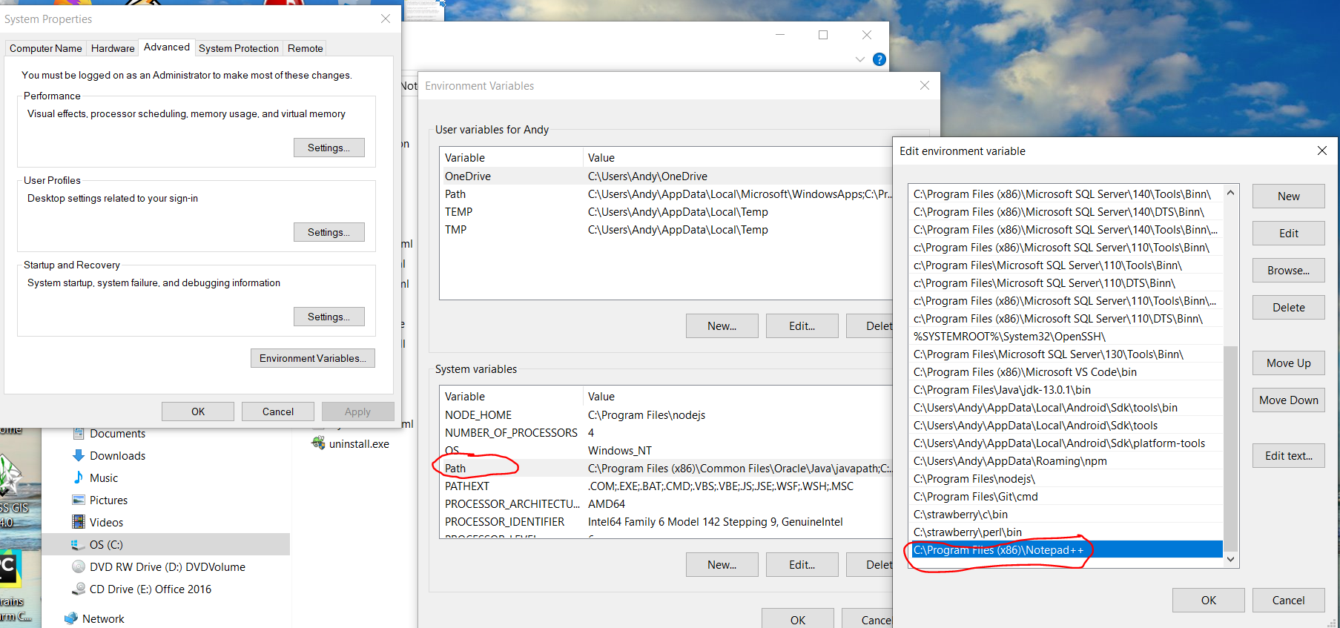

Now when you open ‘Git Bash’ you can type ‘notepad++’ and notepad++ will open.

Now configure Notepadd++ with Git:-
Now go to Git Bash and type the following to create the file - .bash_profile:-
notepad++ .bash_profile
When this file is created add the following to the file:-
alias npp='notepad++.exe --multiInst --nosession'
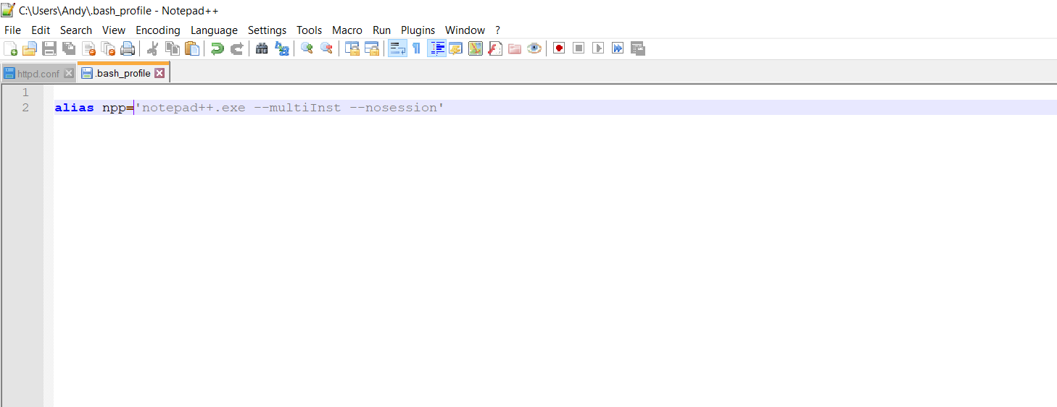

Then save the file.
The close Notepad++

Configure Notepad++ with GIT:-
Open a new Git Bash and enter the following:-
git config --global core.editor "\"C:\Program Files (x86)\Notepad++\notepad++.exe\""

Now relaunch Git Bash and verify of notepad is configured to use Git. Type the following into Git Bash:-
cat ~/.gitconfig

See editor here:-
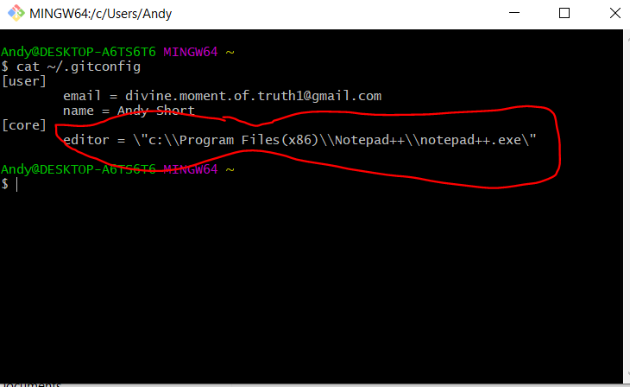
Type the following into Git Bash to edit the global git configuration:-

git config --global –e

Compare file changes:-
Typing the following will tell you which files have changed:-
git status
If the files are red then the files have changed. Type the following to work out what the differences are between versions:-
git diff
Test this by doing the following:-
[1] Create a new folder e.g.:-
C:\Users\Andy\Documents\software\Devops\git files
[2] Create a file in the folder:-
Sample.txt
[3] Add some text to the file and save and close it
[4] Open Git Bash in the folder (C:\Users\Andy\Documents\software\Devops\git files)
[5] type:-
git init
[6] type:-
git status
[7] type:-
git add .
[8] type:-
git commit –m ‘New commit’
[9] Now open sample.txt and add some new text to the file. Then save and close.
[10] Type:-
git status
You will see a red file showing that there has been a change to the file.
[11] Type:-
git diff
this will show you what changes have been made to the file.
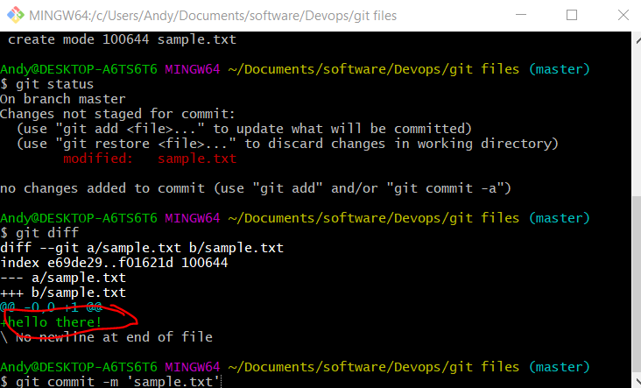
As you can see from the above screen shot that the text ‘hello there!’ has been added to the file.

Working Area – file exists on your pc put has not been added or commited
Staging Area – File has been added – git add .
Repository Area – File has been committed – git commit -m ‘Initial file upload’

Compare Staging area with Repository area:-
Type:-
git diff --staged

Delete files oin Git:-
Method One
First delete the file from your folder (do this in Windows explorer).
In Bit Bash type:-
git status
This will show the deleted file in red.
Now type the following into Git Bash
git add .
Then commit your changes to the Git repo by typing:-
git commit -m ‘Deleted using OS’

Method One
In Bit Bash type:-
git rm filename.txt

In Bit Bash type:-
git status
This will show that the file is green and deleted from the staging area.
Then commit your changes to the Git repo by typing:-
git commit -m ‘File deleted using Git’

GitHub
Go to you Github account and sign in -
https://github.com/divine-moment-of-truth
Create a new repository:-
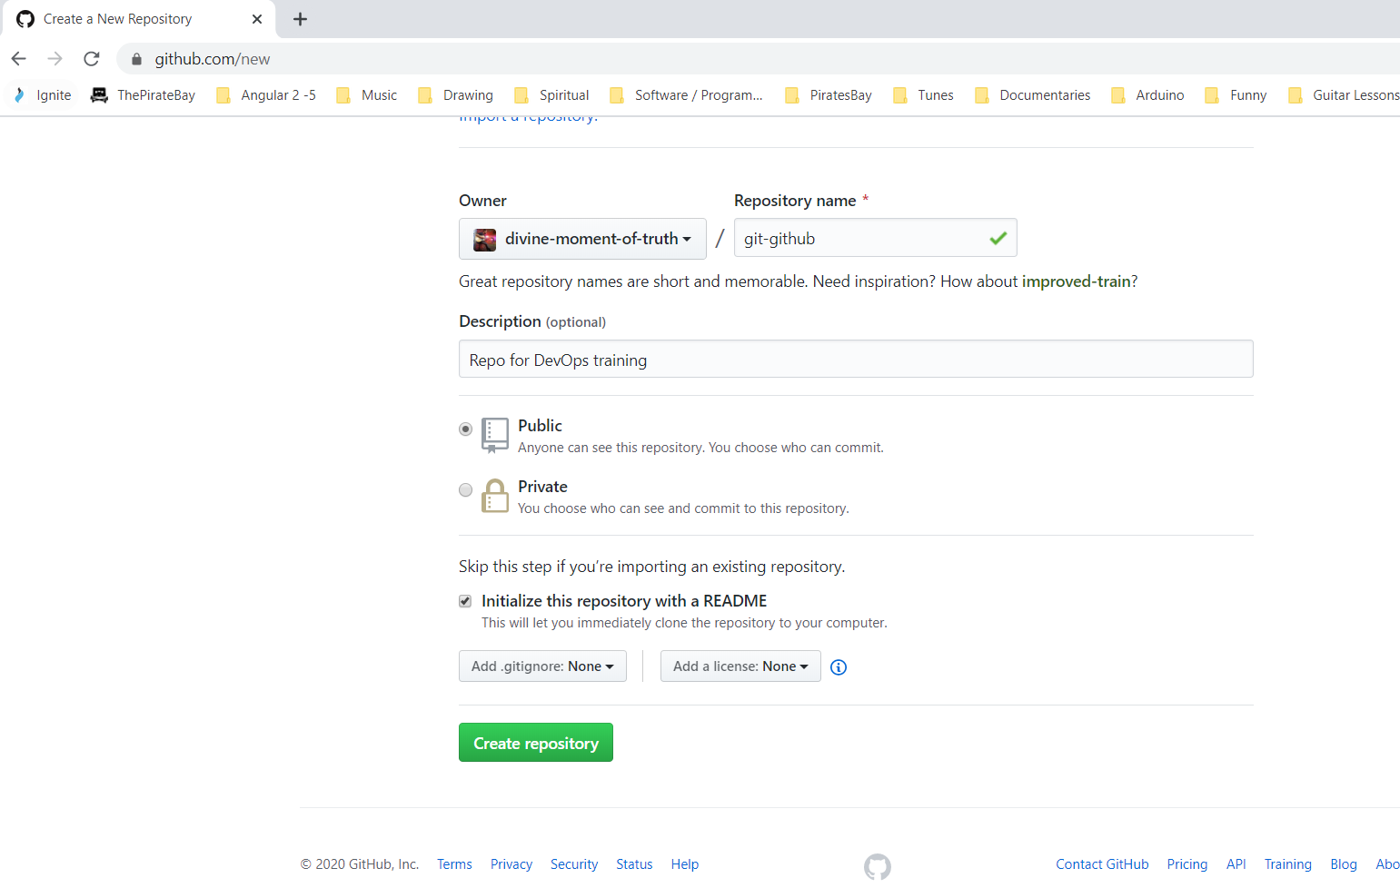

Create a new folder on your desktop with the same name as the repo in GitHib:-
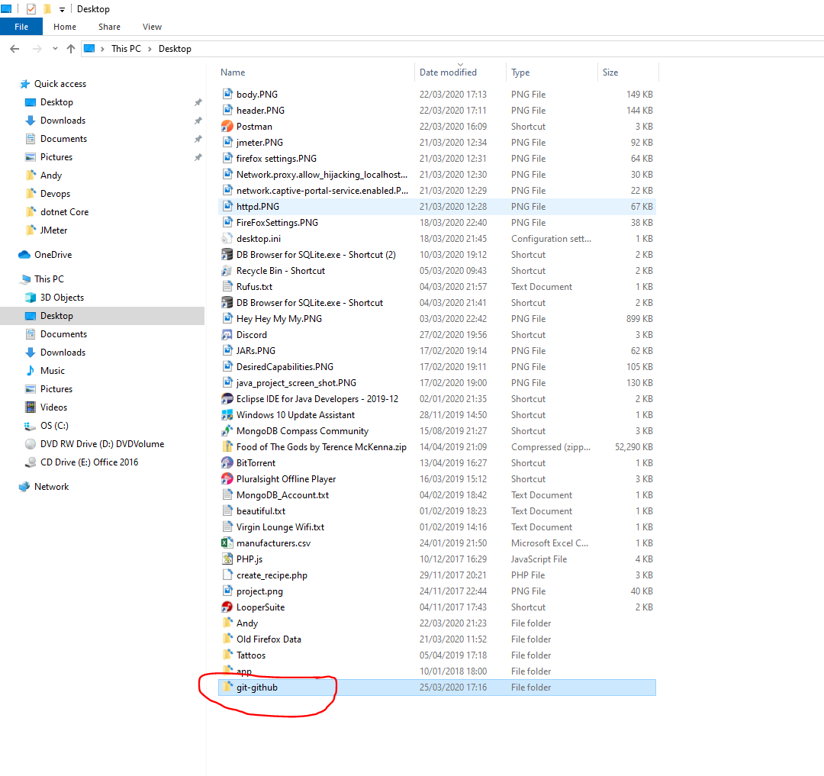
Now navigate inside the ‘git-git-hub’ folder on your desktop and right click anywhere inside and select ‘Open Git Bash Here’:-
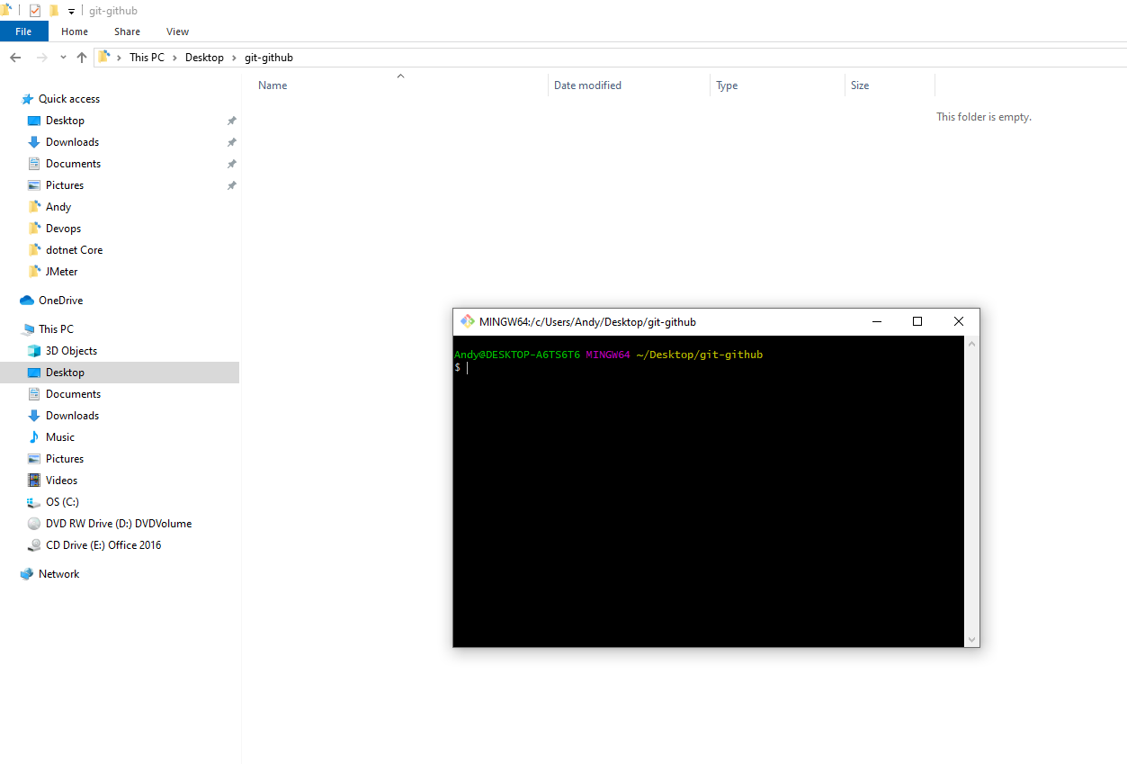

When Git Bash open type:-
git init

Now sink the repo on your pc with the repo in Github. Do this by going to git hub and getting the url of your repo (copy it):-
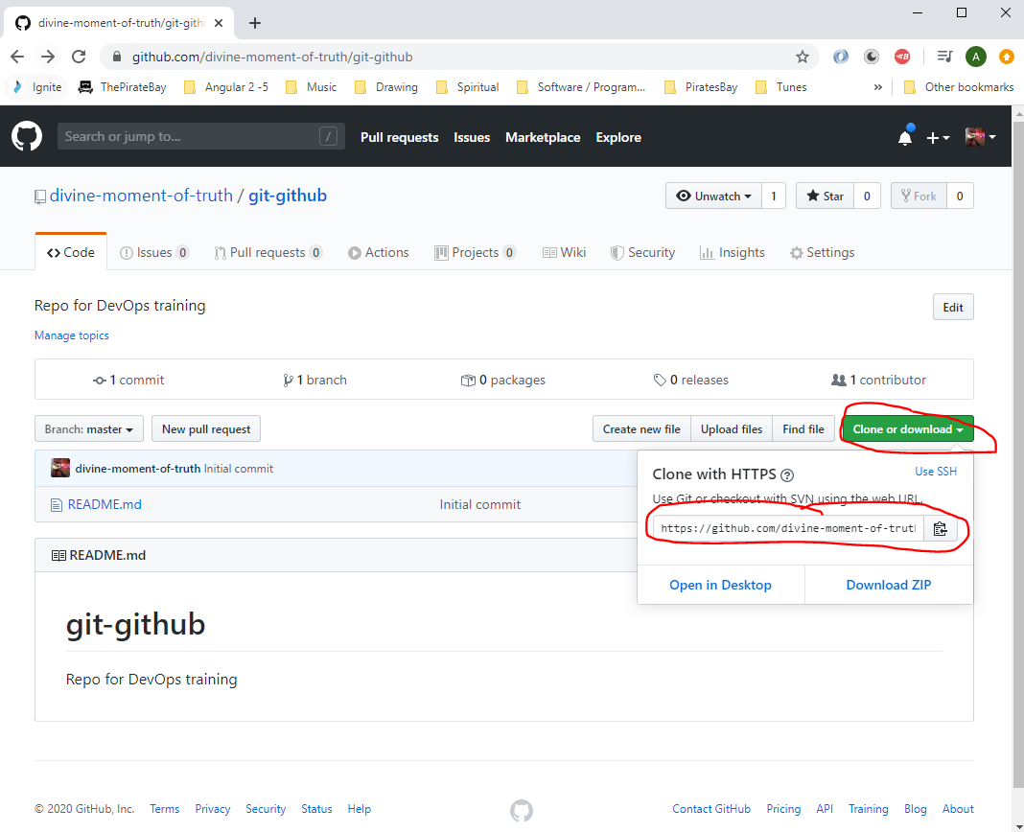

Copy this:-
https://github.com/divine-moment-of-truth/git-github.git

In Git Bash type:-
git remote add origin https://github.com/divine-moment-of-truth/git-github.git

There is a ‘readme.md’ file that exists in the GitHub repo online that does not exist in your repo on your laptop, so you need to get both repos in synch. So you need to do a pull request. Type the following into Git Bash:-
git pull

If at this point you get an error you may need to run this command in Git Bash:-
git remote set-url origin https://github.com/divine-moment-of-truth/git-github.git

Then try again:-
git pull
You will then get this:-
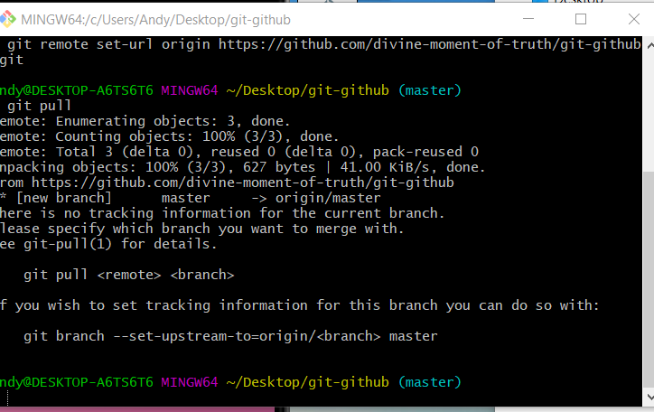
From the message above you need to specify your branch name which can be obtained from here:-
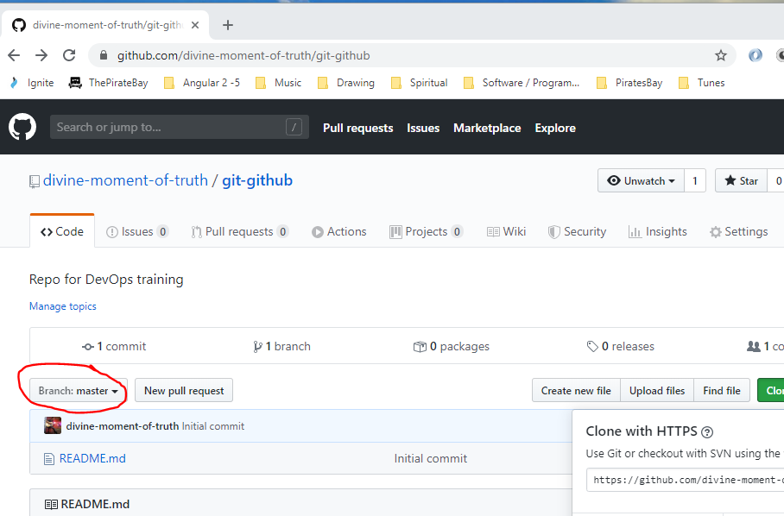

So type the following into Git Bash to get a successful request:-
git pull origin master
You will get this:-
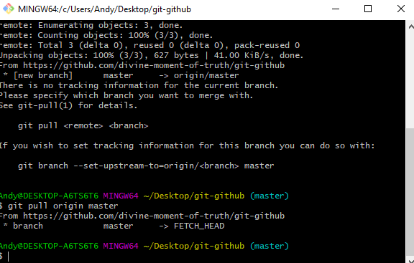

Now check that your local repo has the ‘readme.md’ file in it:-
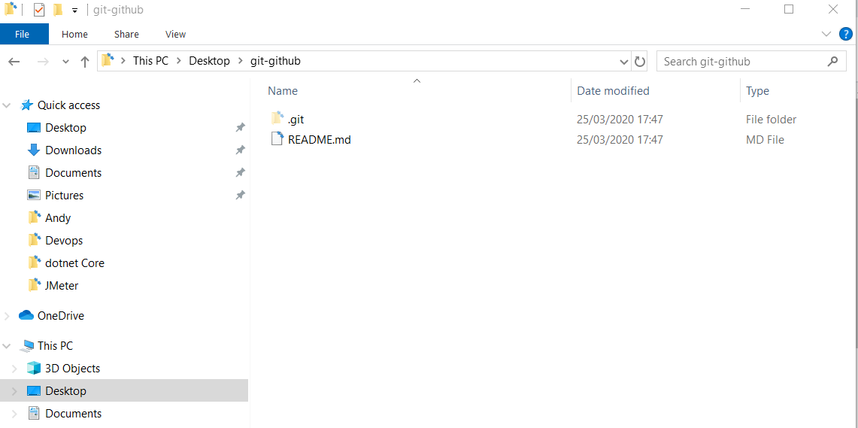

As you can see it does.

Now create a new text file in your local repo:-
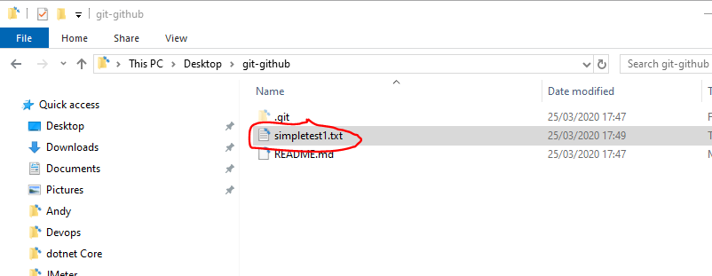

Now PUSH this up to the GitHub repo. In Git Bash type this:-
git status
git add .
git commit -m “My first commit”
git push origin master

Now make some changes to your local copy of the text file and save text file. Then in Git Bash type:-
git status
git add .
git commit -m “Added more text”
git push origin master

Now go to Github and see the updated text file has the changes.

Now create a new file in Github. Click this:-
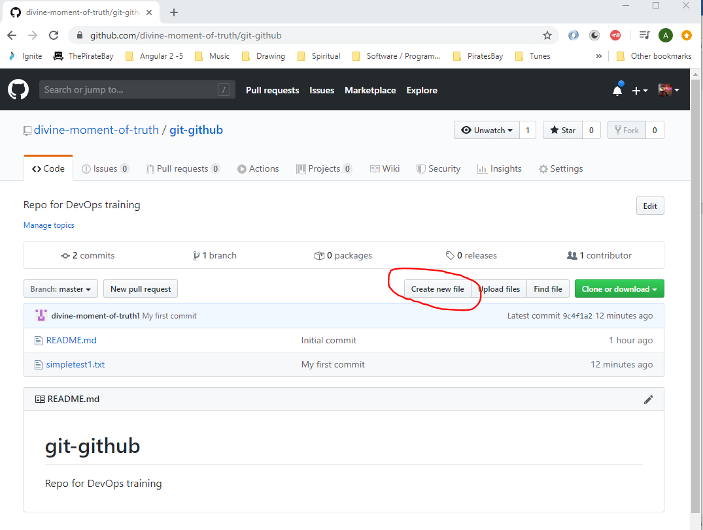
Enter text here:-
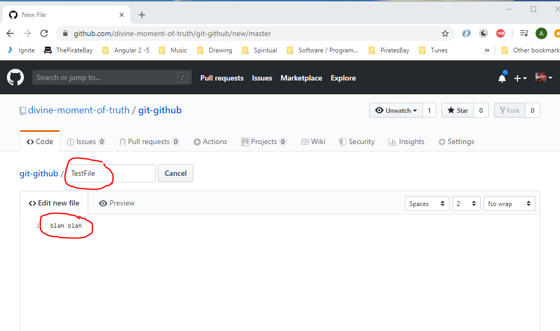

Then click ‘Commit New File’ button:-
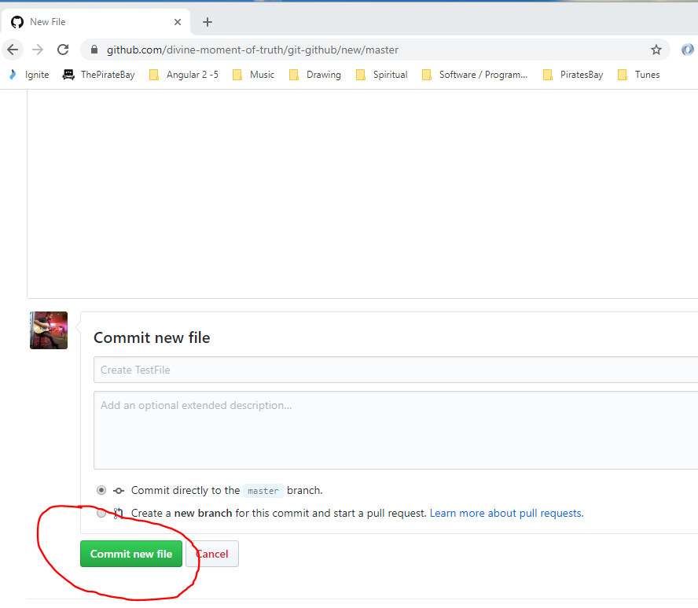

New file is created here:-
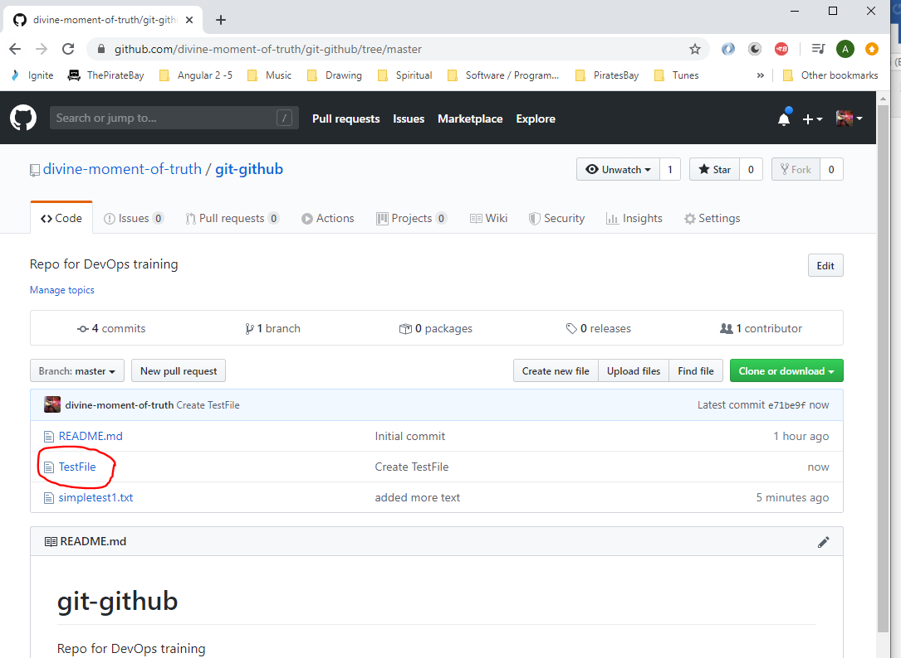

In your local repo you need to synch with the repo in Github. To do this type the following into Git Bash:-
git pull origin master

Now you have the file that was previously created in Git Hub:-
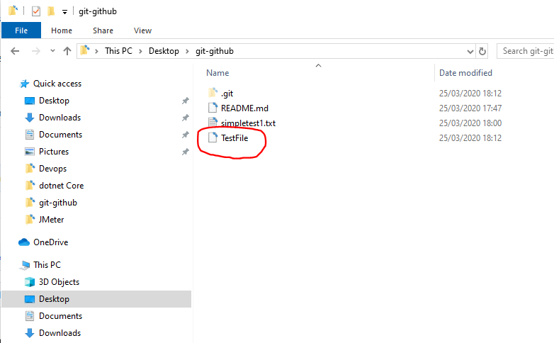

Git Branching
To create a new branch:-
In Git bash type the following to create a branch called ‘dvelop’:-
git branch develop
To switch to the new ‘develop’ branch type the following into Git Bash:-
git checkout develop
To get a lost of the branches type the following into Git Bash:-
git branch
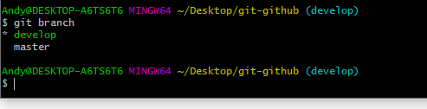
This shows the two branches (‘develop’ is in green because you are in this branch):-
[1] develop
[2] master

To move to the master branch type:-
git checkout master
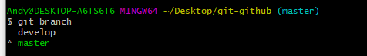
See now that ‘master’ is green (above)

If you type ‘ls’ into Git Bash you will see your files under this branch:-
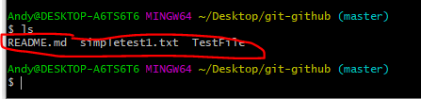
Now, switch back to the ‘develop’ branch by typing:-
git checkout develop
Then type:-
ls
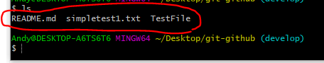
You will again see all the same files that are in ‘master’ because ‘develop’ is a copy of ‘master’.
Now, go to Windows explorer and create two new files in the ‘git-github’ folder called –
simpletest2.txt
simpletest3.txt
Add these two files;-
git status
git add .
git status
git commit -m “Branch develop”
ls

You can now see 5 files:-
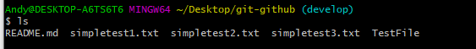

Now switch back to ‘master’ branch:-
git checkout master
ls
You will see that there are still only 3 files in master:-
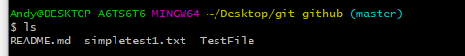

Merging Branches into Master
So ensure you are in the ‘devlop’ branch. Type the following into Git Bash to make sure u r in the ‘develop’ branch:-
git checkout develop
Now to push your develop changes to the master branch type the following:-
git push origin develop

Now if you go to your Github repository in Github you will see thus:-
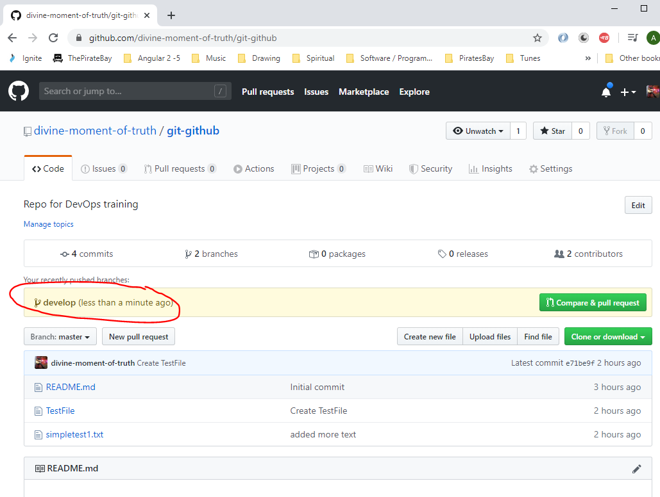

You can see from the drop down below that you now have two brfanches:-
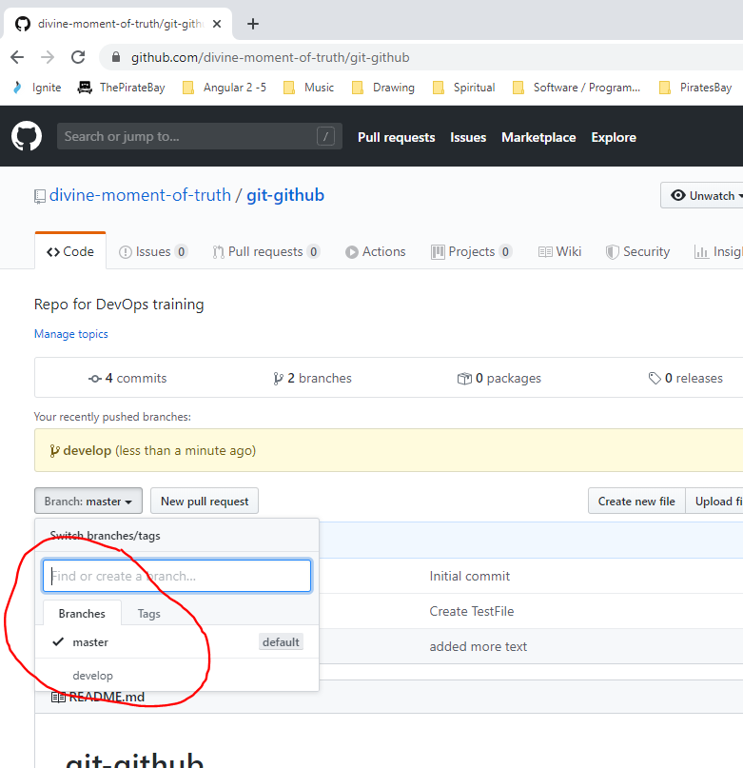

Look you can see the files under the ‘develop’ branchL0
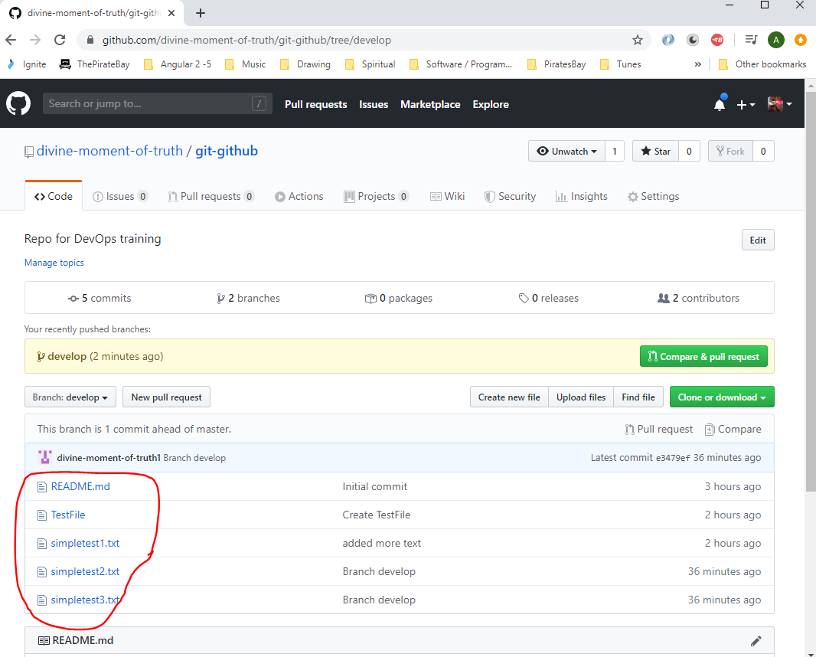

And you can see the files under the ‘master’ branch:-
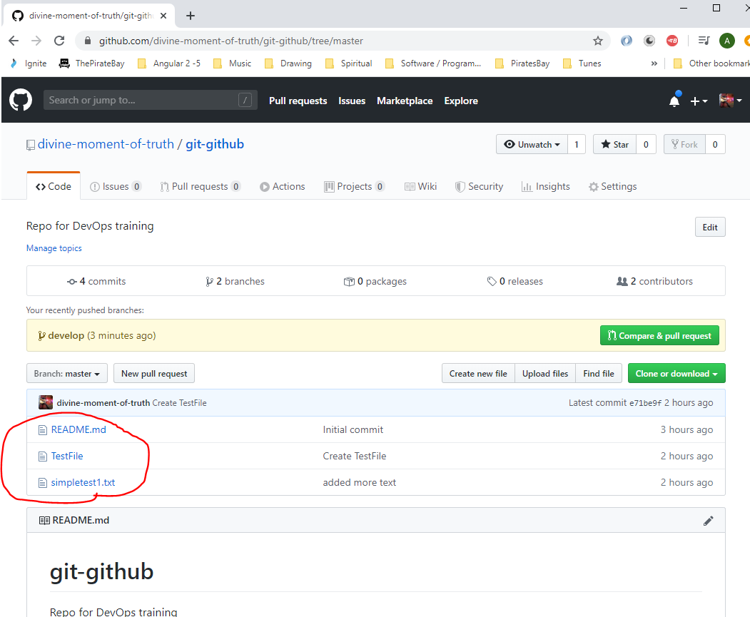

Now to actually move the files from ‘develop’ branch to the ‘master’ branch do the following in Git Bash:-
git checkout master
git merge develop
git push origin master

Now, you can see the files pushed from the ‘develop’ branch now added to the ‘master branch:
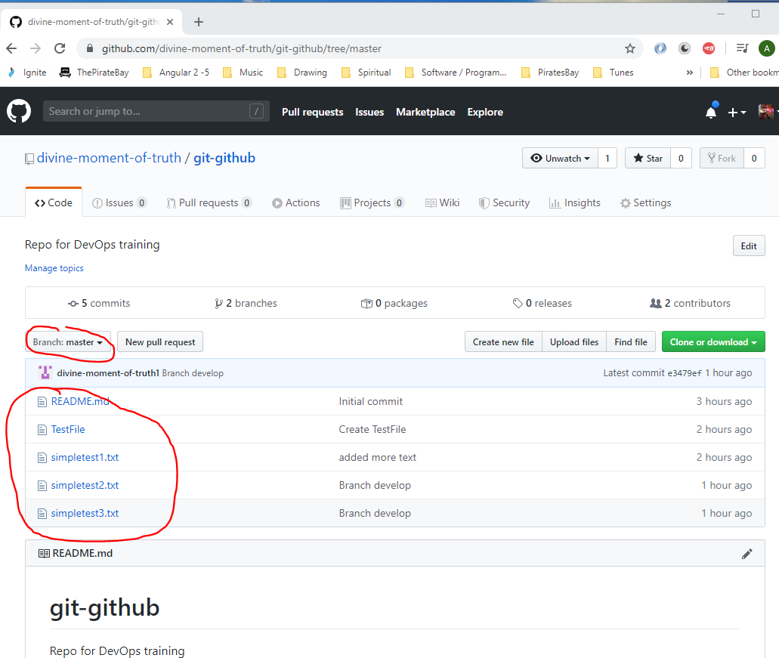

Reverting Git Commits
Modify one of your files i.e. open the following file ad make some changes then click ‘Save’:-
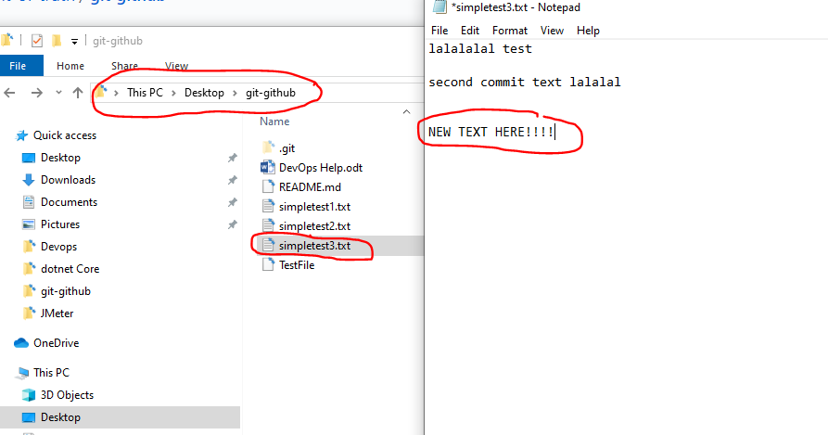

Now it Gt Bash type:-
git status
You will see that the file is red:-
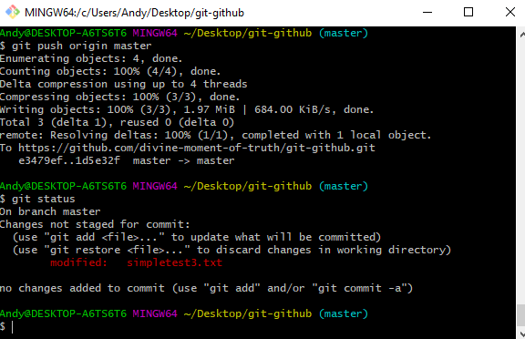

Do a ‘git diff’ to see changes:-
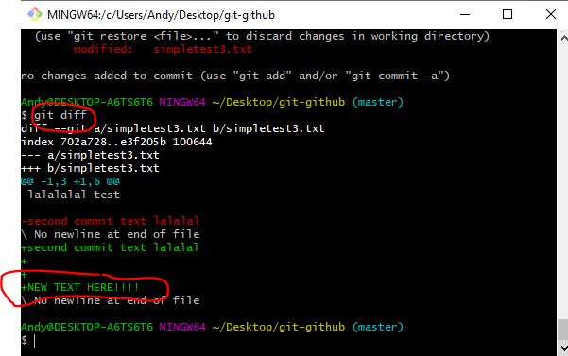

In Git Bash type to move changed file into the ‘staging’ area:-
git add .
Now if you realise that you have made a mistake in the file. Type the following into Git Bash to unstage the changes:-
git reset HEAD simpletest3.txt

type:-
git status
You will now see that the file has gone back to red:-
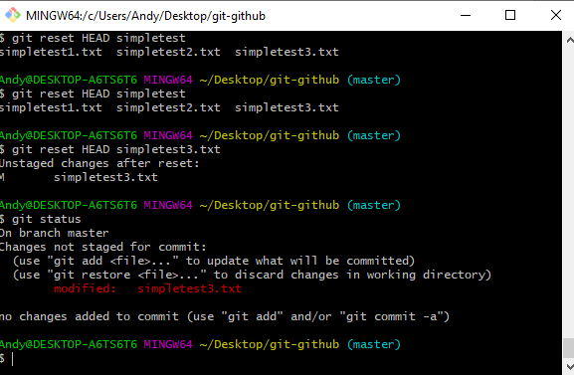

To revert a commited file do this:-
To show how this works we will commit an edited file first:-
git add .
git commit -m “reverting example”

Now to revert your changes (say you realise you have made a mistake in your committed file):-
git reset HEAD~
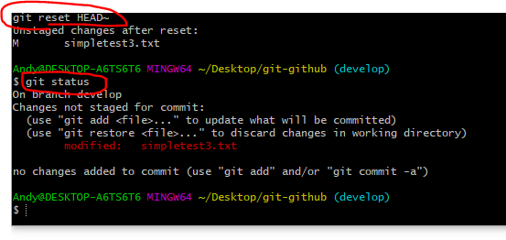
Typing ‘git status’ will then show that the file has gone back to the red state (above).
GIT Basics
Adding GIT to an existing project

